Purpose and audience
This site is intended to advertise lawn services to potential and existing customers. It will contain a description of services as well as contact info to receive a quote other customer service

Color scheme
Forest Green: #1E5631
Leaf Green: #4CAF50
Golden Yellow: #FFD166
Soft Off-White: #F8F9F6
Charcoal: #2E2E2E

Fonts to be used
Verdana
Georgia
Playfair Display

Content
Hero text:
(playfair display) ClearPath Services
(Vedana) Reach out to receive a free quote!
clearpath@cleapath.com facebook.com
Footer
(Verdana) Contact us!
clearpath@cleapath.com facebook.com

Hometext part 1:
Seasonal Services (Verdana, bold)
(Georgia) From autumn leaf removal to winter snow clearing, ClearPath Services handles it all. We offer comprehensive solutions tailored to your property’s needs, including driveways, sidewalks, yards, and commercial areas. No pile is too large, and no snowfall is too heavy—our goal is a clear path for you, every time.
Hometext part 2:
Why choose us? (Verdana, bold)
(Georgia) At ClearPath Services, we believe a clean, safe, and accessible outdoor space makes all the difference. Our mission is simple: to provide reliable, professional leaf and snow removal services so you can enjoy your property without the stress of seasonal cleanup. Whether it’s a crisp fall day or a snowy winter morning, we’ve got you covered!

Services part 1:
Leaf Removal (Verdana, bold)
(Georgia) Our leaf removal service ensures your property stays neat and safe throughout the fall season. We remove leaves from yards, driveways, sidewalks, and commercial spaces, preventing slip hazards and lawn damage. ClearPath makes seasonal cleanup effortless so you can enjoy the beauty of autumn without the mess.

Services part 2:
Snow Removal (Verdana, bold)
(Georgia) When winter hits, ClearPath keeps your property accessible and safe. From driveways to walkways and parking lots, we provide prompt snow plowing, shoveling, and de-icing services. Heavy snowfall is no match for our team—we clear the way so you can focus on what matters most.

About us text:
About Us (Verdana, bold)
(Georgia) At ClearPath Services, we are passionate about keeping your outdoor spaces safe, accessible, and beautiful, no matter the season. Founded on reliability, professionalism, and attention to detail, our team takes pride in handling both leaf and snow removal with efficiency and care. We believe that a clear path makes life easier, and our goal is to provide peace of mind to every homeowner and business we serve.
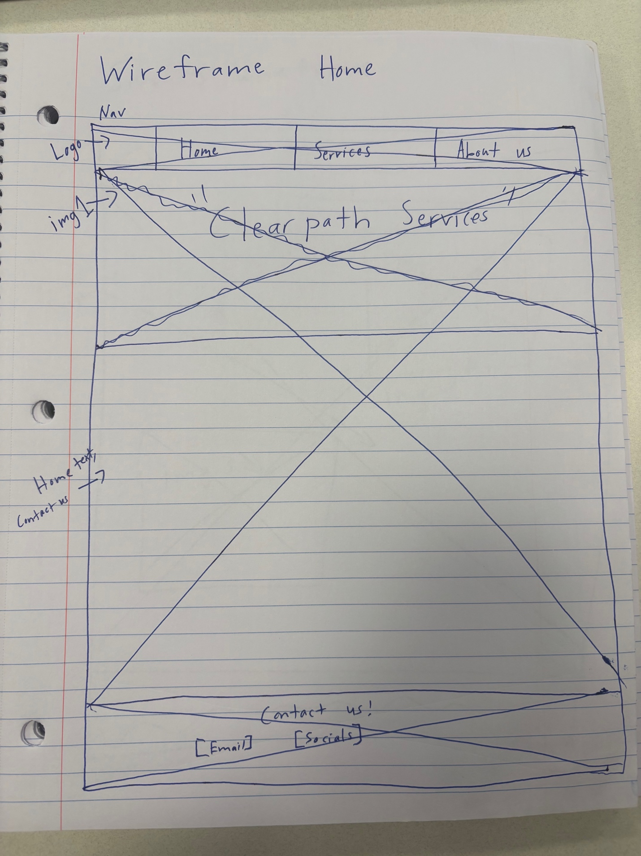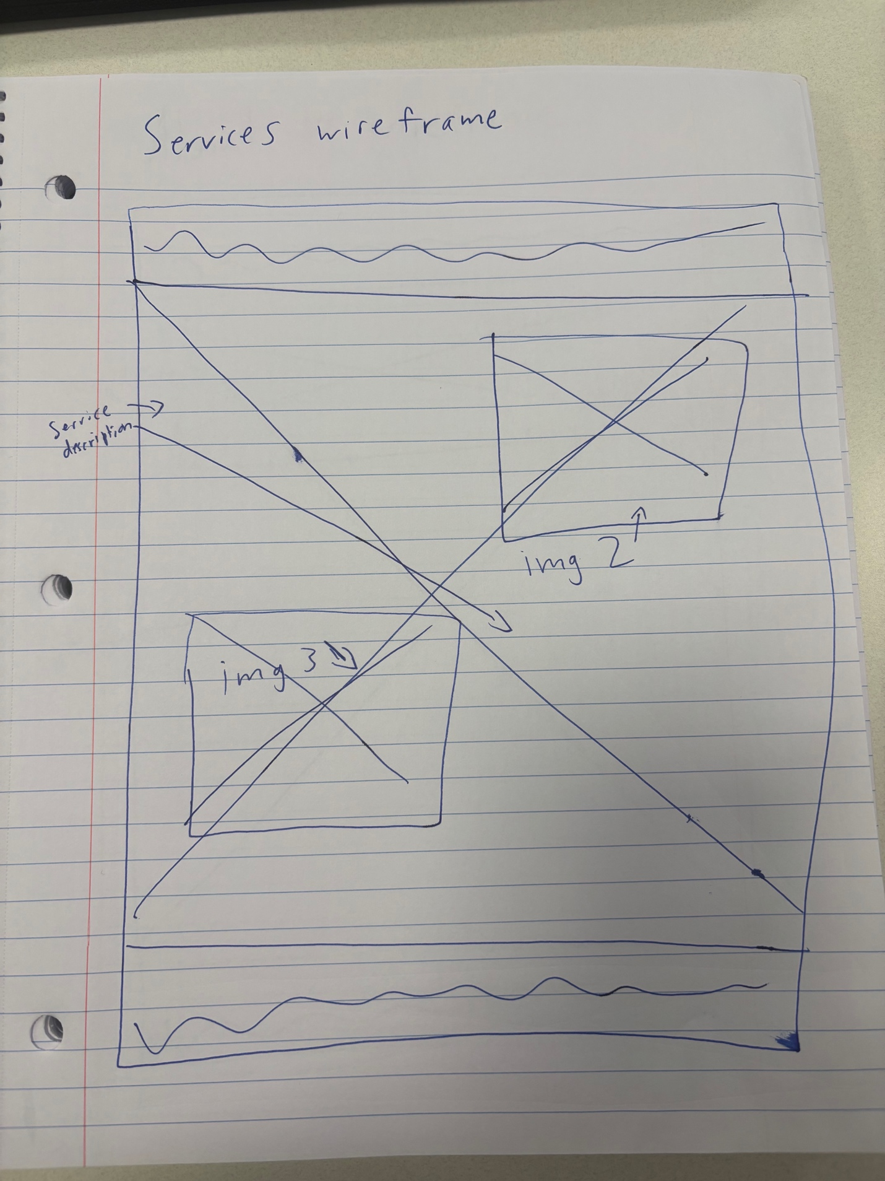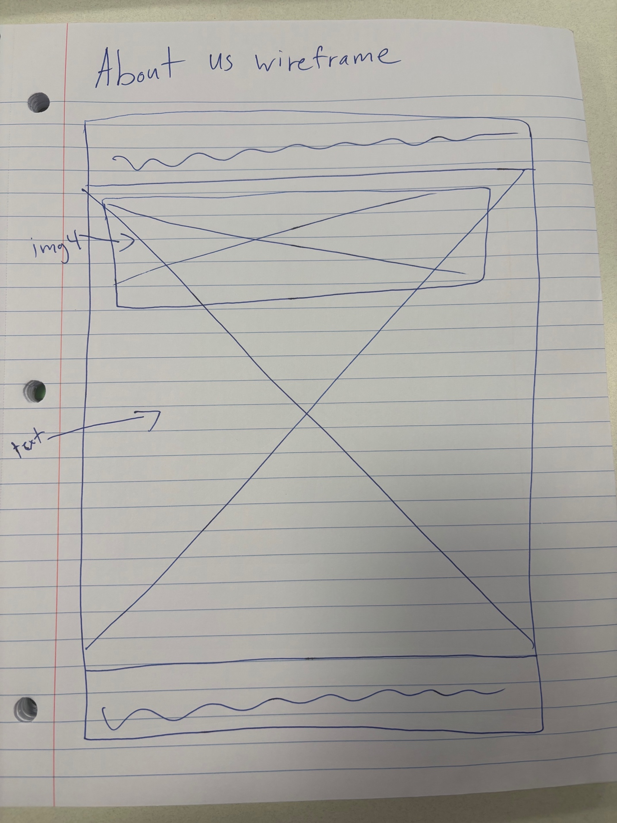

Img 1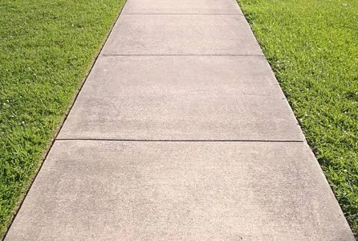
Img 2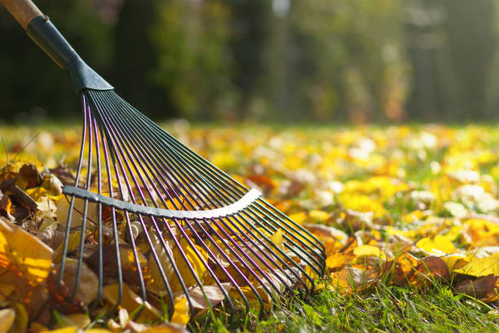
img 3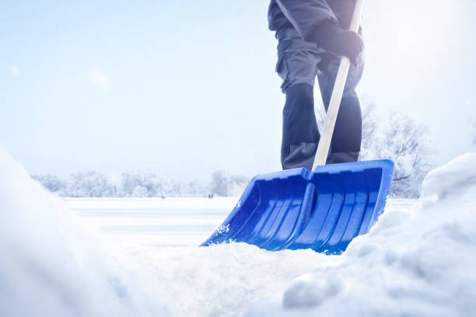
Img 4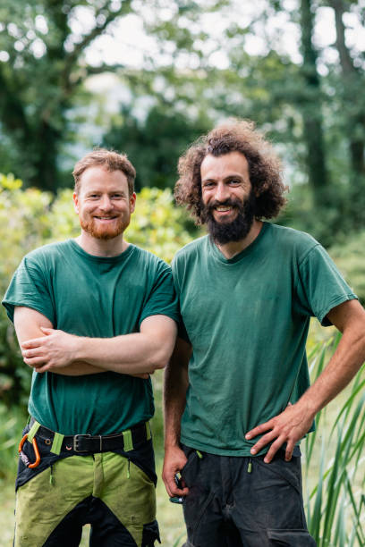
leaf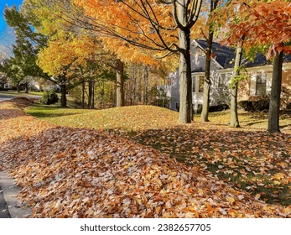
logo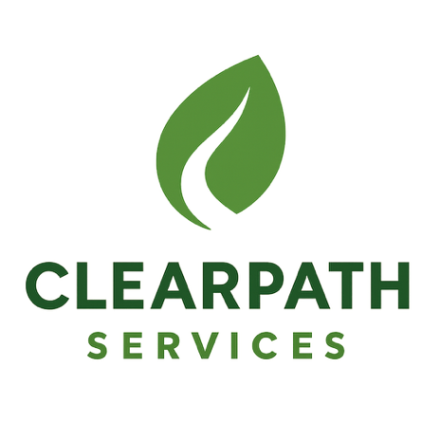
snow